## horizontal line



Clinical Data Analysis and Predictions of the trends in patient admissions and severity of diseases.

04.06.2022

**─**

Vivek Pandith D V

Department of Artificial Intelligence and Machine Learning,

Bangalore Institute of Technology,

Bengaluru.

# Overview

As we all know how difficult it is to handle unanticipated medical situations, here comes a service that predicts the number of patients who would get admitted on a particular day, with a particular disease. So that medical staff can be prepared and work accordingly.

# Goals

1. Reduce Medical discrepancies due to situational anxiety.
2. Reduce the uncertainty of the number of patients and organizing.

# Specifications

In the project, I have used three approaches to make predictions. Namely,

1. Long-Short-Term-Memory(LSTM) - Classical Deep Learning approach
2. Long-Short-Term-Memory(LSTM) with Autoencoder- Gives the best results.
3. FBProphet. - Preliminary and more user-friendly.

# Data

In this project, I have currently used German clinics’ datasets comprising features like ICD codes, OPS codes, Case sum, Admission date and time, length of stay, and clinic names.

# Algorithm

1. Import required modules and Merge all the datasets.
2. Preliminary data analysis.
3. Feature Engineering including Label encoding.
4. Splitting the data into Train and Test sets.
5. Define LSTM, AutoEncoder and Prophet.
6. Training the models using appropriate features.
7. Testing and evaluation.
8. Summarise predictions and compare the models.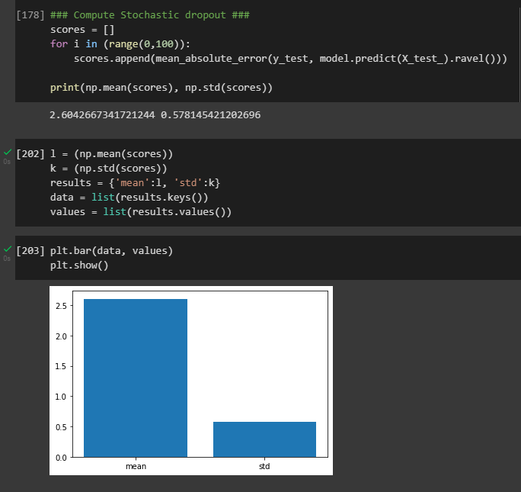

The loss incurred is 8.9821% and the validation loss incurred is 9.0950%